**CCNA 2 Final Exam 2012 v.2**

May 3rd, 2012 [Dragos](http://blog.ddos-protection.eu/author/dragos-gaftoneanu/) [Leave a comment](http://blog.ddos-protection.eu/cisco/ccna-2-final-exam-2012-v-2/#respond) [Go to comments](http://blog.ddos-protection.eu/cisco/ccna-2-final-exam-2012-v-2/#comments)

**1. Which of the following are required when adding a network to the OSPF routing process configuration? (Choose three.)**  
**network address**  
loopback address  
autonomous system number  
subnet mask  
**wildcard mask  
area ID**

**2. Which of the following are primary functions of a router? (Choose two.)**  
**packet switching**  
microsegmentation  
domain name resolution  
**path selection**  
flow control

[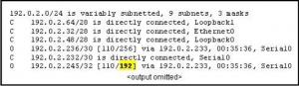](http://blog.ddos-protection.eu/wp-content/uploads/3-ccna2-v3.png)

**3. Refer to the routing table shown in the exhibit. What is the meaning of the highlighted value 192?**  
It is the value assigned by the Dijkstra algorithm that designates the number of hops in the network.  
It is the value used by the DUAL algorithm to determine the bandwidth for the link.  
**It is the metric, which is cost.**  
It is the administrative distance.

**4. Which three statements are true regarding the encapsulation and de-encapsulation of packets when traveling through  
a router? (Choose three.)**  
**The router modifies the TTL field, decrementing it by one.**  
The router changes the source IP to the IP of the exit interface.  
**The router maintains the same source and destination IP.  
The router changes the source physical address to the physical address of the exit interface.**  
The router changes the destination IP to the IP of the exit interface.  
The router sends the packet out all other interfaces, besides the one it entered the router on.

[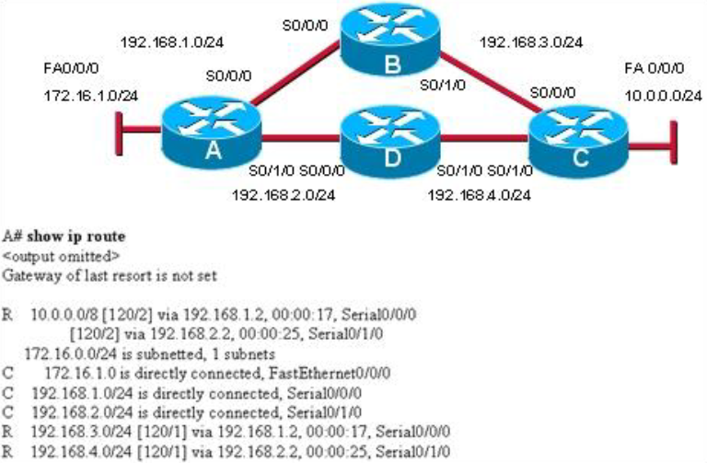](http://blog.ddos-protection.eu/wp-content/uploads/4-ccna2-v2.png)

**Refer to the exhibit. Which path will traffic from the 172.16.1.0/24 network take to get to the 10.0.0.0/24 network?**  
ADC  
ABC  
**It will load balance the traffic between ADC and ABC**  
It will send the traffic via ABC, and will use ADC as a backup path only when ABC fails.

**5. What is the purpose of the TTL field within an IP packet header?**  
clears an unreachable route from the routing table after the invalid timer expires  
prevents regular update messages from inappropriately reinstating a route that may have gone bad  
removes an unreachable route from the routing table after the flush timer expires  
**limits the period of time or number of hops a packet can traverse through the network before it should be discarded**  
used to mark the route as unreachable in a routing update that is sent to other routers

[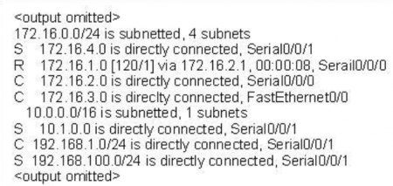](http://blog.ddos-protection.eu/wp-content/uploads/6-ccna2-v2-e1336246834901.png)

**6. Refer to the exhibit. How many routes are both level 1 and qualify for use as an ultimate route?**  
1  
**2**  
3  
4  
5  
6

[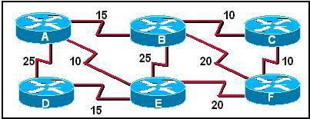](http://blog.ddos-protection.eu/wp-content/uploads/7-ccna2-v2.png)

**7. Refer to the exhibit. Cost for each path are shown. If all routers are configured to use OSPF, what would be the path of a packet sent from Router C to Router D if Router A was down?**  
C-B-E-D  
C-B-A-D  
**C-F-E-D**  
C-F-B-A-D  
C-F-E-A-D

[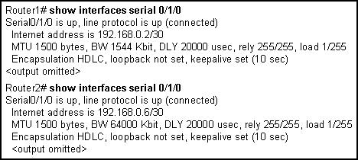](http://blog.ddos-protection.eu/wp-content/uploads/8-ccna2-v2.png)

**8. Refer to the exhibit. Routers 1 and 2 are directly connected over a serial link. Pings are failing between the two routers. What change by the administrator will correct the problem?**  
Set the encapsulation on both routers to PPP.  
Decrease the bandwidth on Serial 0/1/0 on router 2 to 1544.  
Change the cable that connects the routers to a crossover cable.  
**Change the IP address on Serial 0/1/0 on router 2 to 192.168.0.1/30.**

**[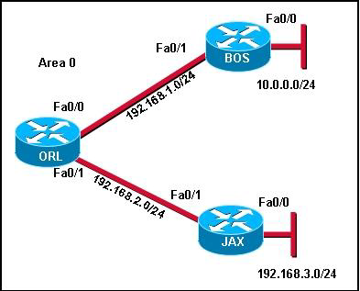](http://blog.ddos-protection.eu/wp-content/uploads/9-ccna2-v2.png)**

**9. Refer to the exhibit. A network administrator is trying to determine why router JAX has no OSPF routes in its routing table. All routers are configured for OSPF area 0. From the JAX router, the administrator is able to ping its connected interfaces and the Fa0/1 interface of the ORL router but no other router interfaces. What is a logical step that the network administrator should take to troubleshoot the problem?**  
Reboot the routers.  
Change the OSPF process ID on all of the routers to 0.  
Check to see if the cable is loose between ORL and JAX.  
Check to see if CDP packets are passing between the routers.  
**Use show and debug commands to determine if hellos are propagating**

**[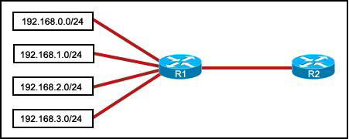](http://blog.ddos-protection.eu/wp-content/uploads/10-ccna2-v2.png)**

**10. Refer to the exhibit. Which summarization should R1 use to advertise its networks to R2?**  
192.168.1.0/24  
192.168.0.0/24  
**192.168.0.0/22**  
192.168.1.0/22

**11. A router boots and enters setup mode. What is the reason for this?**  
The IOS image is corrupt.  
Cisco IOS is missing from flash memory.  
**The configuration file is missing from NVRAM.**  
The POST process has detected hardware failure.

[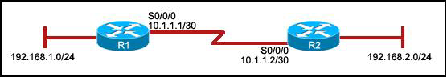](http://blog.ddos-protection.eu/wp-content/uploads/12-ccna2-v2.png)

**12. Refer to the exhibit. R1 is configured properly for a single area OSPF, and R2 has been recently installed in the network. Which set of commands is required to configure a single area OSPF for the networks that are connected to R2?**  
**R2(config)# router ospf 1  
R2(config-router)# network 192.168.2.0 0.0.0.255 area 0  
R2(config-router)# network 10.1.1.0 0.0.0.3 area 0**  
R2(config)# router ospf 1 R2(config-router)# network 192.168.2.0 0.0.0.255 area 0 R2(config)# router ospf 2 R2(config-router)# network 10.1.1.0 0.0.0.3 area 0  
R2(config)# router ospf 1 R2(config-router)# network 192.168.2.0 0.0.0.255 area 0 R2(config-router)# network 10.1.1.0 0.0.0.3 area 1  
R2(config)# router ospf 1 R2(config-router)# network 192.168.2.0 0.0.0.255 area 0 R2(config-router)# network 10.0.0.0 0.0.0.3 area 1

[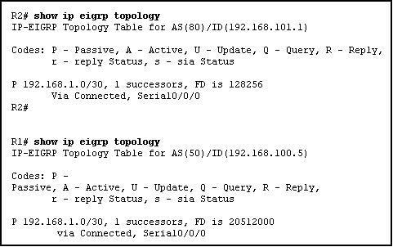](http://blog.ddos-protection.eu/wp-content/uploads/13-ccna2-v2.png)

**13. Refer to the exhibit. Routers R1 and R2 are directly connected via their serial interfaces and are both running the EIGRP routing protocol. R1 and R2 can ping the directly connected serial interface of their neighbor, but they cannot form an EIGRP neighbor adjacency.  
What action should be taken to solve this problem?**  
Enable the serial interfaces of both routers.  
Configure EIGRP to send periodic updates.  
Configure the same hello interval between the routers.  
**Configure both routers with the same EIGRP process ID**

**[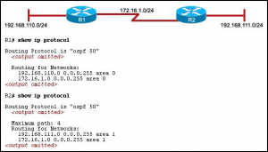](http://blog.ddos-protection.eu/wp-content/uploads/ccna-2-14.png)**

**14. Refer to the exhibit. The hosts that are connected to R2 are unable to ping the hosts that are connected to R1. How can this problem be resolved?**  
Configure the router ID on both routers.  
**Configure the R2 router interfaces for area 0.**  
Configure a loopback interface on both routers.  
Configure the proper subnet masks on the router interfaces.

**15. In a lab test environment, a router has learned about network 172.16.1.0 through four different dynamic routing processes. Which route will be used to reach this network?**  
**D 172.16.1.0/24 [90/2195456] via 192.168.200.1, 00:00:09, Serial0/0/0**  
O 172.16.1.0/24 [110/1012] via 192.168.200.1, 00:00:22, Serial0/0/0  
R 172.16.1.0/24 [120/1] via 192.168.200.1, 00:00:17, Serial0/0/0  
I 172.16.1.0/24 [100/1192] via 192.168.200.1, 00:00:09, Serial0/0/0

**16. Which statement is true about the metrics used by routing protocols?**  
**A metric is a value used by a particular routing protocol to compare paths to remote networks.**  
A common metric is used by all routing protocols.  
The metric with the highest value is installed in the routing table.  
The router may use only one parameter at a time to calculate the metric

[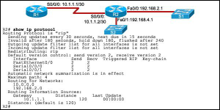](http://blog.ddos-protection.eu/wp-content/uploads/ccna-2-17.png)

**17. Refer to the exhibit. Both routers are using the RIPv2 routing protocol and static routes are undefined. R1 can ping  
192.168.2.1 and 10.1.1.2, but is unable to ping 192.168.4.1.  
What is the reason for the ping failure?**  
The serial interface between two routers is down.  
R2 is not forwarding the routing updates.  
**The 192.168.4.0 network is not included in the RIP configuration of R2.**  
RIPv1 needs to be configured.

**18. Which two statements are true about the EIGRP successor route? (Choose two.)**  
It is saved in the topology table for use if the primary route fails.  
It may be backed up by a feasible successor route.  
**It is used by EIGRP to forward traffic to the destination.**  
It is flagged as active in the routing table.  
After the discovery process has occurred, the successor route is stored in the neighbor table

[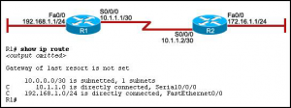](http://blog.ddos-protection.eu/wp-content/uploads/ccna-2-19.png)

**19. Refer to the exhibit. Hosts on the 192.168.1.0 network cannot communicate with hosts on the 172.16.1.1 network. The network administrator has run the show ip route command on R1. What could be the cause of this problem?**  
The FastEthernet interface on R1 is disabled.  
Autosummarization is enabled on R1.  
The serial interface S0/0/0 of R1 is administratively down.  
**No static route or routing protocol is configured.**

**20. Which statement correctly describes a feature of RIP?**  
RIP is a link-state routing protocol.  
**RIP uses only one metric—hop count— for path selection.**  
Advertised routes with hop counts greater than 10 are unreachable.  
Messages are broadcast every 10 seconds

[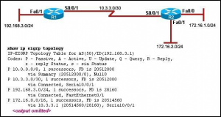](http://blog.ddos-protection.eu/wp-content/uploads/ccna-2-21.png)

**21. Refer to the exhibit. Which two statements are true based on the exhibited output? (Choose two.)  
All routes are stable.**  
Each route has one feasible successor.  
The serial interface between the two routers is down.  
The administrative distance of EIGRP has been set to 50.  
**The show ip eigrp topology command has been run on R1.**

**22. A network administrator is analyzing routing update behavior on a network that has both EIGRP and OSPF  
configured on all routers. Both protocols appear in the output of show ip protocols. However, only EIGRP internal  
routes appear in the routing tables. Which statement correctly explains the scenario?**  
The OSPF protocol has a higher cost than EIGRP.  
The EIGRP protocol has a lower metric than OSPF.  
The EIGRP protocol was configured first on the router.  
**The EIGRP protocol has a lower administrative distance than OSPF**

**23. Which prompt is used to allow a user to change the IP address of an interface on a router?**  
Router>  
Router#  
Router(config)#  
**Router(config-if)#**

**[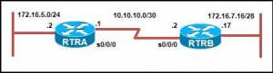](http://blog.ddos-protection.eu/wp-content/uploads/ccna-2-24.png)**

**24. Refer to the exhibit. Routers RTRA and RTRB are running OSPF. What entry does RTRA add in the routing table  
when Serial 0/0/0 receives an update about the network that is attached to RTRB?**  
O 172.16.7.0/30 [110/51] via 10.10.10.2, 00:00:25, Serial0/0/0  
**O 172.16.7.16/28 [110/51] via 10.10.10.2, 00:00:25, Serial0/0/0**  
O 172.16.7.0/24 [110/51] via 10.10.10.2, 00:00:25, Serial0/0/0  
O 172.16.0.0/16 [110/51] via 10.10.10.2, 00:00:25, Serial0/0/0

**25. Which additional piece of information is included in the updates of classless routing protocols to support the use of VLSM and discontiguous networks?**  
metric  
**network mask**  
neighbor router ID  
administrative distance

**26. Because of a topology change, the next hop IP address in the current static route must be reconfigured. How can a static route entry be altered to accommodate a topology change?**  
Keep the existing static route and configure a new static route with the correct next hop IP address.  
**Negate the existing static route and configure a new static route with the correct next hop IP address.**  
Do nothing. The existing static route will automatically update the next hop entry with the new IP address.  
Keep the existing static route, reload the router, and configure a new static route with the correct next hop IP address

**27. Which router mode is accessed by entering the enable command?**  
user EXEC  
**privileged EXEC**  
global configuration  
interface configuration

[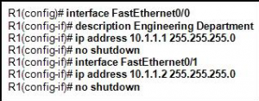](http://blog.ddos-protection.eu/wp-content/uploads/ccna-2-28.png)

**28. Refer to the exhibit. An administrator is attempting to configure a router by copying and pasting the commands that are shown in the exhibit. However, only one of the FastEthernet interfaces is coming up. What is the problem?**  
**Both interfaces are in the same IP subnet.**  
FastEthernet0/1 does not have a description.  
There can be only one FastEthernet interface enabled on a router at one time.  
The administrator did not exit to global configuration mode before configuring FastEthernet0/1

**29. In an examination of two OSPF routers that fail to exchange information, it is determined that they have not become OSPF neighbors. Which two configuration values must match for the OSPF routers to become neighbors?**  
neighbor ID and router ID  
**dead time and hello time**  
OSPF area and neighbor ID  
OSPF area and interface priority

[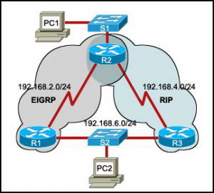](http://blog.ddos-protection.eu/wp-content/uploads/ccna-2-30.png)

**30. Refer to the exhibit. Routers R1 and R3 use different routing protocols with default administrative distance values. All devices are properly configured and the destination network is advertised by both protocols. Which path will be used to transmit the data packets from PC1 to PC2?**  
**The packets will travel via R2-R1.**  
The packets will travel via R2-R3.  
The traffic will be load-balanced between two paths — via R2-R1 and via R2-R3.  
The packets will travel via R2-R3, and the other path via R2-R1 will be retained as the backup path

[http://blog.ddos-protection.eu/wp-content/uploads/ccna-2-31-300x52.png](http://blog.ddos-protection.eu/wp-content/uploads/ccna-2-31.png)

**31. Refer to the exhibit. The network administrator has run the following command on R1. R1(config)# ip route 192.168.2.0 255.255.255.0 172.16.1.2 What is the result of running this command?**  
**Traffic for network 192.168.2.0 is forwarded to 172.16.1.2.**  
This route is automatically propagated throughout the entire network.  
Traffic for all networks is forwarded to 172.16.1.2.  
The command invokes a dynamic routing protocol for 192.168.2.0

**32. Why is fast convergence desirable in networks that use dynamic routing protocols?**  
Hosts are unable to access their gateway until the network is converged.  
Routers will not allow packets to be forwarded until the network is converged.  
**Routers may make incorrect forwarding decisions until the network has converged.**  
Routers will not allow configuration changes to be made until the network has converged

**33. Which two statements about routing protocols are accurate? (Choose two.)**  
**OSPF supports VLSM.**  
RIPv1 supports VLSM.  
RIPv2 does not have a hop count limit.  
**EIGRP supports discontiguous network designs.**  
RIPv2 does not support discontiguous network designs

[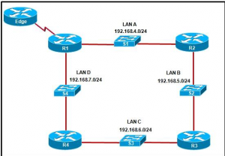](http://blog.ddos-protection.eu/wp-content/uploads/ccna-2-34.png)

**34. Refer to the exhibit. If the EIGRP routing protocol is used throughout the network, which IP address and mask prefix  
should be sent by router R1 to the Edge router as a result of manual summarization of LANs A, B, C, and D?**  
192.168.4.0/20  
**192.168.4.0/22**  
192.168.4.0/24  
192.168.4.0/26

[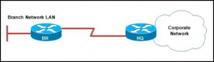](http://blog.ddos-protection.eu/wp-content/uploads/ccna-2-35.png)

**35. Refer to the exhibit. Which solution provides the most efficient use of router resources for forwarding traffic between BR and HQ?**  
RIP  
RIPv2  
EIGRP  
**static routes**

**[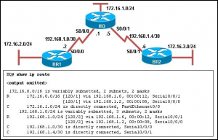](http://blog.ddos-protection.eu/wp-content/uploads/ccna-2-36.png)**

**36. Refer to the exhibit. The network is configured with RIPv2. However, network administrators notice that communication cannot be successfully completed from one LAN to another. A network administrator issues the show ip route command on the HQ router. Based on the output, what should be done to correct the problem?**  
Disable the load balancing feature of RIPv2.  
**Issue the no auto-summary command for RIPv2.**  
Replace RIPv2 with EIGRP which supports VLSM.  
Make sure that the network statements include the correct subnet mask

**37. Which protocol is used by EIGRP to deliver and receive update packets?**  
FTP  
**RTP**  
TCP  
TFTP  
UDP

**38. Which multicast address does EIGRP use to send hello and updates packets?**  
224.0.0.5  
224.0.0.6  
224.0.0.9  
**224.0.0.10**

**39. A network administrator is using an application that is monitoring packets on the network and sees an EIGRP update packet. What is the purpose of the update packet?**  
The packet is sent to discover neighbors within the EIGRP network.  
The packet is sent to search for network devices within an EIGRP network.  
**The packet is used to propagate routing information within the EIGRP network.**  
The packet is used to send an unreachable reply to another router within the EIGRP network.  
The packet is used to notify all routers that EIRGP has failed on one of the routers within the EIGRP network

[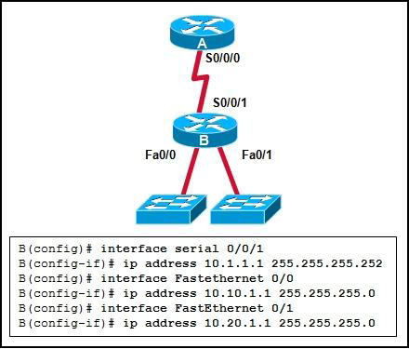](http://blog.ddos-protection.eu/wp-content/uploads/ccna-2-40.png)

**40. Refer to the exhibit. What OSPF network statements are required for the router B to advertise the three networks that are attached?**  
router ospf 1 network 10.0.0.0 0.0.0.255 area 0  
router ospf 1 network 10.1.1.0 0.3.255.255 area 0 network 10.10.1.0 0.255.255.255 area 0 network 10.20.1.0 0.255.255.255 area 0  
router ospf 1 network 10.1.1.0 0.0.0.3 area 0 network 10.10.1.0 0.0.255.255 area 0 network 10.20.1.0 0.0.255.255 area 0  
**router ospf 1 network 10.1.1.0 0.0.0.3 area 0 network 10.10.1.0 0.0.0.255 area 0 network 10.20.1.0 0.0.0.255 area 0**

**[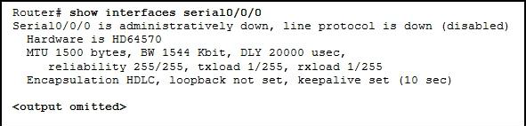](http://blog.ddos-protection.eu/wp-content/uploads/ccna-2-41.png)**

**41. Refer to the exhibit. Why is the state of the serial0/0/0 interface administratively down?**  
An IP address has not been configured on the interface.  
The WIC was installed into the incorrect slot on the router.  
The default encapsulation on the interface has been modified.  
**The no shutdown command has not been executed on the interface**

**42. On a router, which three components are stored in RAM? (Choose three.)**  
POST code  
**the routing table**  
**the running-configuration**  
the start-up configuration  
the bootstrap instructions  
**a copy of the operating system**

**[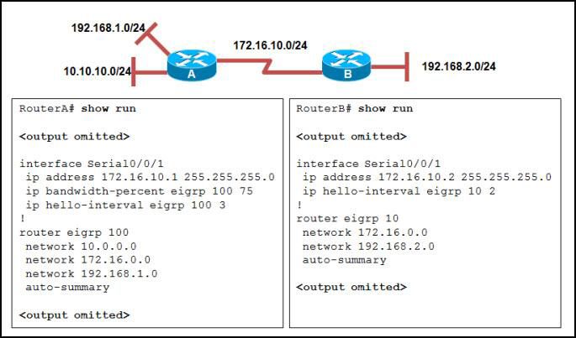](http://blog.ddos-protection.eu/wp-content/uploads/ccna-2-43.png)**

**43. Refer to the exhibit. RouterA and RouterB cannot successfully exchange EIGRP routes. What is the problem?**  
The hello intervals do not match.  
**The autonomous system numbers do not match.**  
The no auto-summary command is missing from both routers.  
The ip bandwidth-percent command is missing from RouterB

[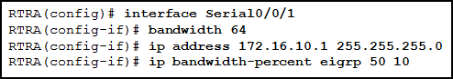](http://blog.ddos-protection.eu/wp-content/uploads/ccna-2-44.png)

**44. Refer to the exhibit. What is the purpose of the ip bandwidth-percent eigrp 50 10 command?**  
**to limit the bandwidth EIGRP packets can use to 6.4 kb/s**  
to limit the bandwidth EIGRP packets can use to 10 kb/s  
to limit the bandwidth EIGRP packets can use to 32 kb/s  
to limit the bandwidth EIGRP packets can use to 50 kb/s

**45. A network administrator adds the default-information originate command to the configuration of a router that uses RIP as the routing protocol. What will result from adding this command?**  
The router will be reset to the default factory information.  
The router will not forward routing information that is learned from other routers.  
**The router will propagate a static default route in its RIP updates, if one is present.**  
The router will only forward packets that originate on directly connected networks

**46. A network technician is configuring a Cisco 2811 router. The technician types conf at the privileged level command prompt and presses the TAB key. What action will the router take?**  
It will revert to the user mode.  
**It will perform an auto-complete function.**  
It will go into the global configuration mode.  
It will give an error message that indicates a bad command was entered

**47. What is a function of the console port on a router?**  
**It is used to manage the router.**  
It is used for packet receiving and forwarding.  
It is used to interconnect various types of LANs.  
It is used to interconnect a variety of serial links including T1, DSL, and ISDN

[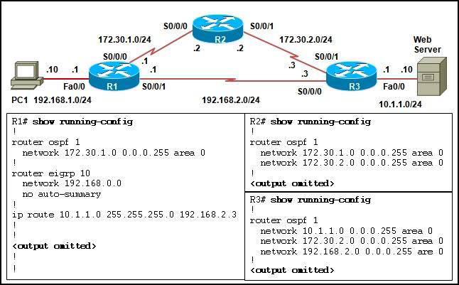](http://blog.ddos-protection.eu/wp-content/uploads/ccna-2-48.png)

**48. Refer to the exhibit. Which route will be installed in the routing table on R1 to forward traffic from PC1 to the web server?**  
**the static route**  
the route learned via OSPF  
the route learned via EIGRP  
both routes learned via OSPF and EIGRP

[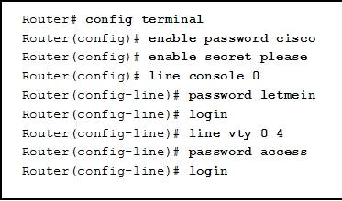](http://blog.ddos-protection.eu/wp-content/uploads/ccna-2-49.png)

**49. Refer to the exhibit. After the commands are entered, which password will be required to establish a Telnet session  
with the router?**  
cisco  
letmein  
please  
**access**